AERO1005 MATLAB Coursework 2

Author: Shi Wen LIANG
Student ID: 20721914
Date of report: 05/05/2026

For questions which require you to write text (i.e., descriptive sentences), or include images and graphs, please add them to the Word submission template.
Preliminary task
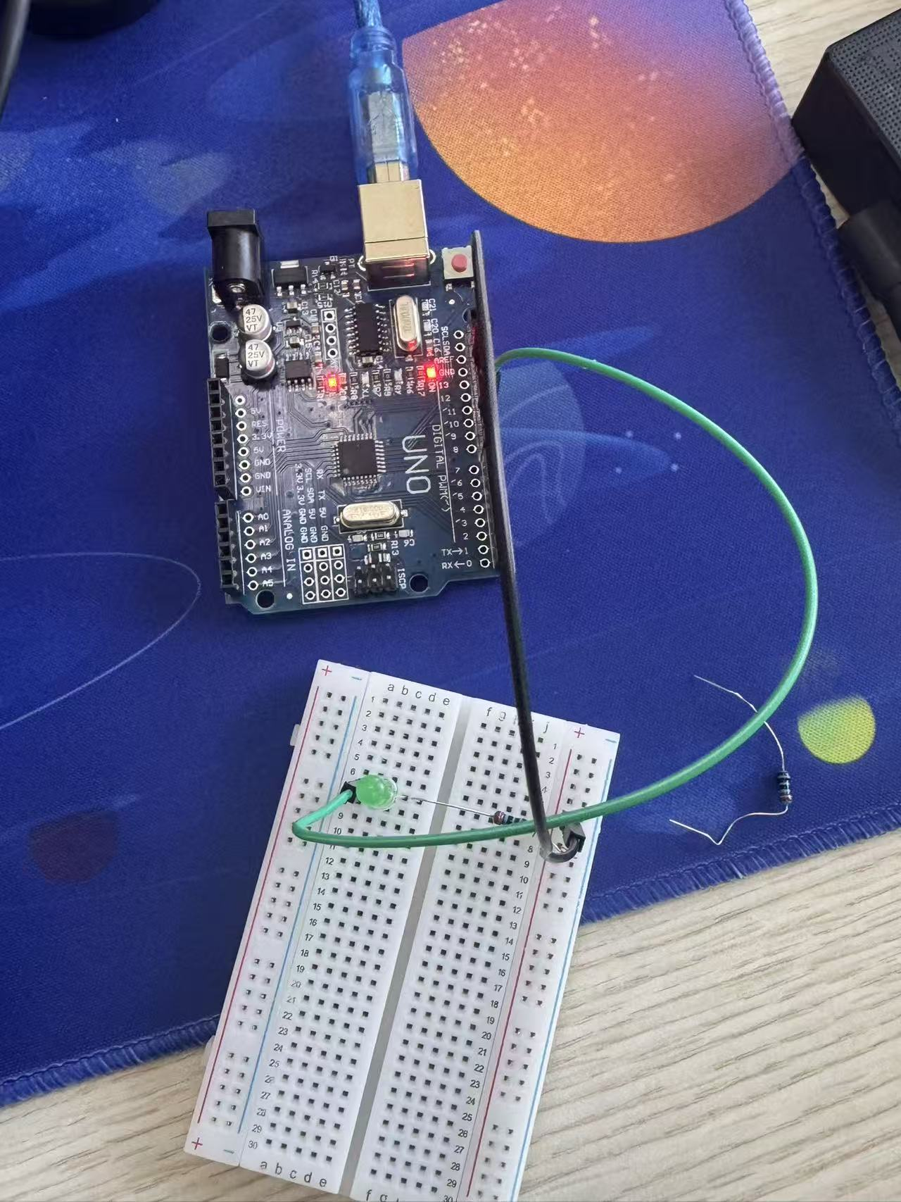

Task 1
Graph (test)
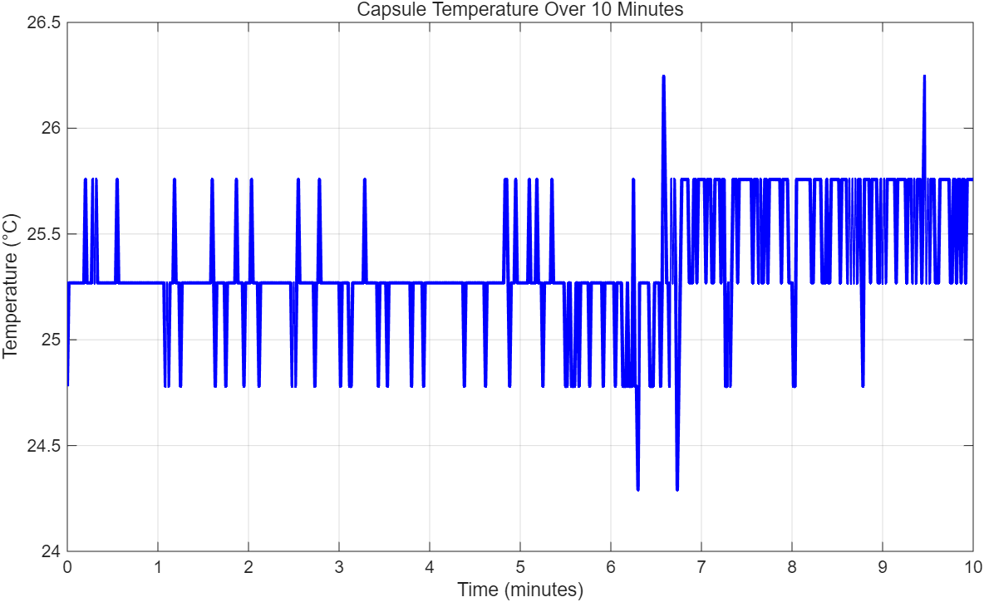
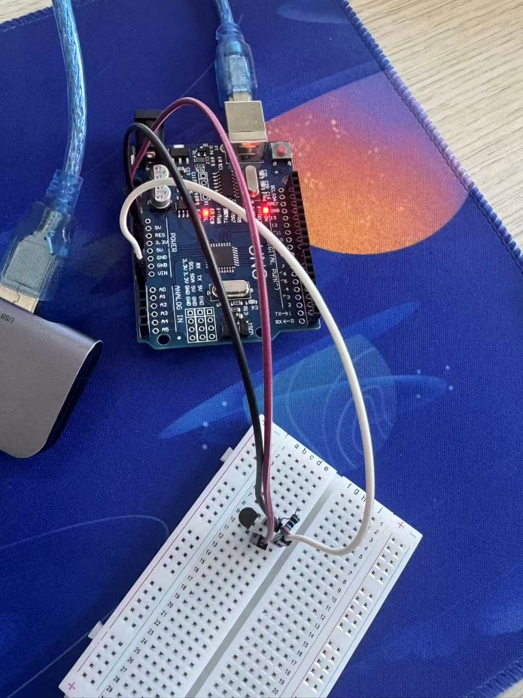

Task 2
(i)
This function provides a real-time temperature monitoring interface for the spacecraft crew capsule. It continuously acquires data from the thermistor via the Arduino object, converting voltage to Celsius to update a live graphical plot with appropriate axes and scaling. The function implements a safety logic: it maintains a constant green LED when the temperature is within the 18-24 C comfort range. If the temperature drops below 18 C, a yellow LED blinks every 0.5 s, and if it exceeds 24 C, a red LED blinks every 0.25 s.\n.

Flowchart 1
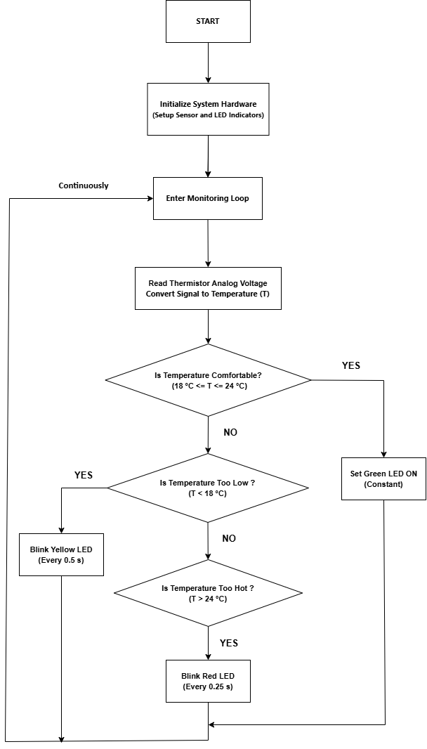
Task 2
Flowchart 2
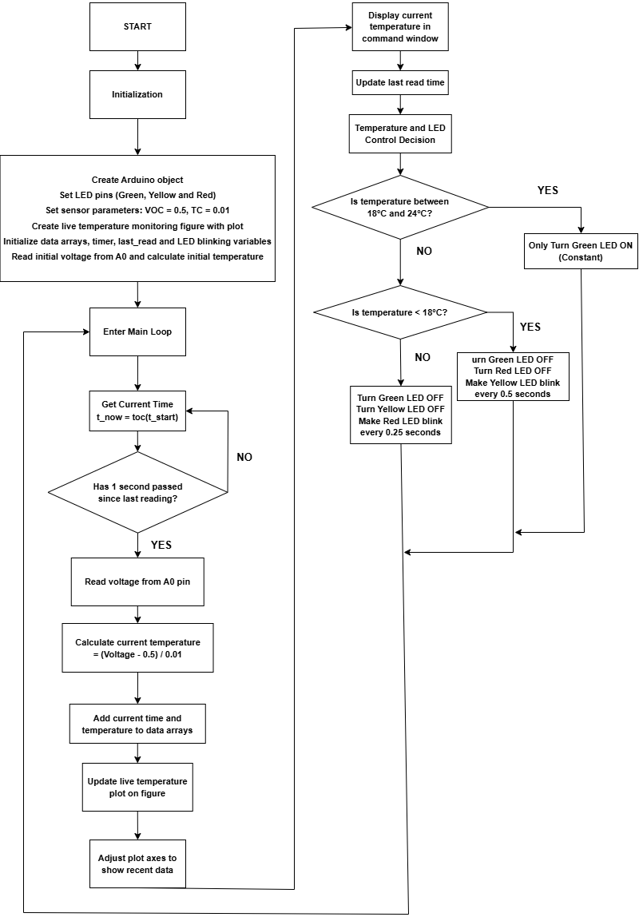
Task 2 & Task 3 image
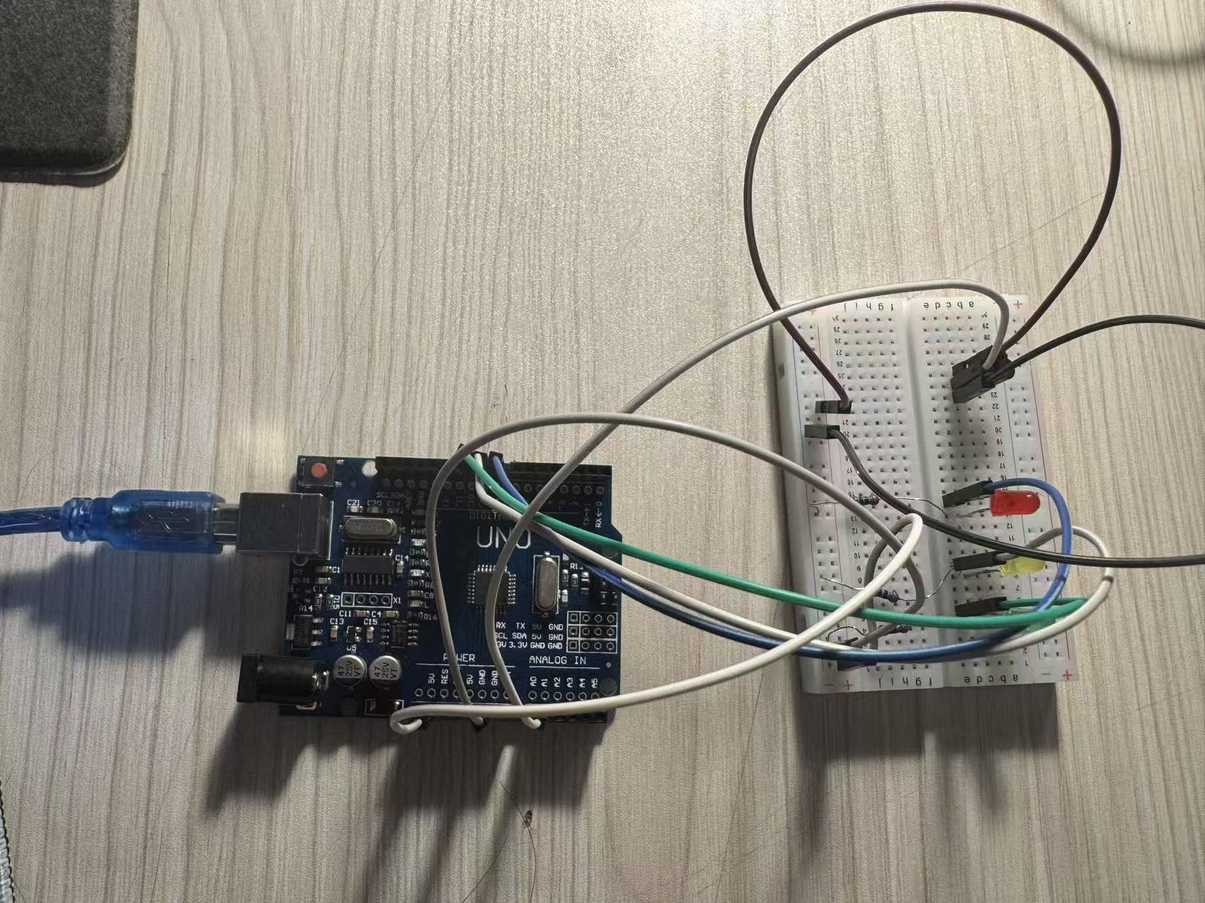
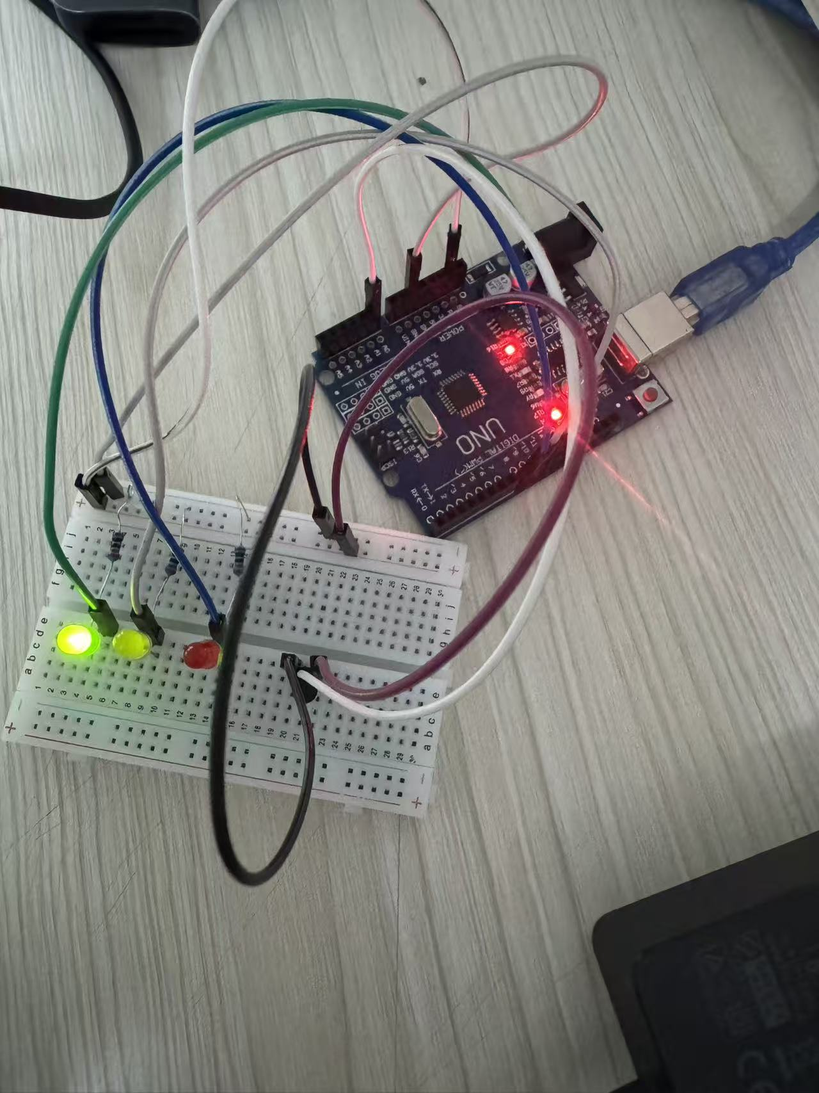
Task 3
% e)
The temp prediction function extends safety monitoring by analyzing the rate of temperature change (degC/s). By calculating the derivative of the collected data, it filters noise to predict the capsule temperature five minutes into the future. Beyond threshold monitoring, it provides early warnings based on volatility: a constant red light activates if the temperature rises faster than +4 degC/min, and a constant yellow light activates for decreases exceeding -4 degC/min. This allows the crew to proactively adjust cabin controls before comfort limits are breached.\n.

Flowchart
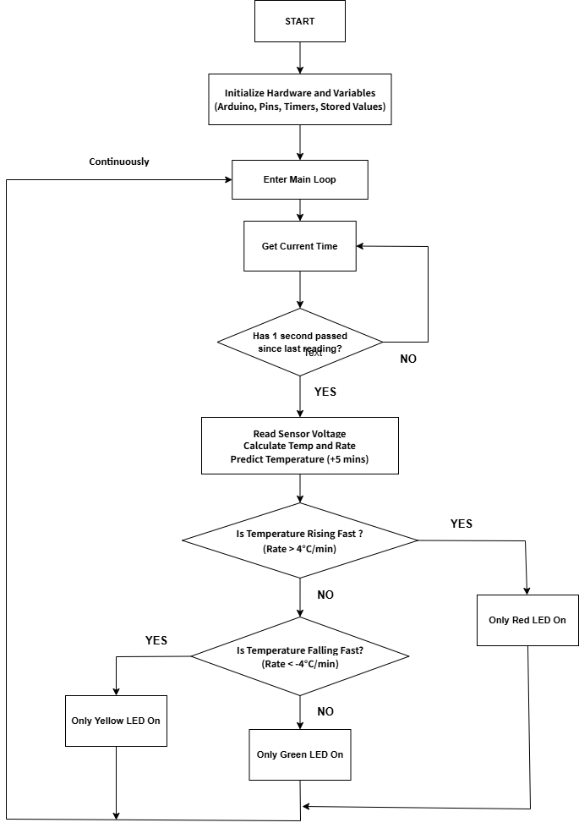

Task 4
Challenges
The primary challenge during implementation was synchronizing MATLAB's real-time plotting with the Arduino's hardware response. In Task 2, frequent calls to plot and drawnow significantly increased loop latency, which interfered with the LED blinking intervals, making the 0.5s and 0.25s periods inconsistent. On the hardware side, the thermistor readings were unstable due to minor voltage fluctuations in the Arduino’s 5V rail. These fluctuations created high-frequency noise that, if left unprocessed, would have been amplified during the derivative calculations in Task 3, leading to inaccurate temperature change rates.
Strengths
The strength of this design lies in the robustness of data processing. To mitigate sensor noise, I implemented a simple moving average filter within temp_prediction.m. By averaging the five most recent samples, I smoothed the $dT/dt$ curve and ensured a reliable prediction output. Furthermore, the code follows strict modularity by passing the Arduino object a as a parameter, maintaining workspace independence and ensuring that the LED logic remains stable without flickering at the 18℃ or 24℃ boundary conditions.
Limitations
The current implementation has hardware limitations, specifically the disorganized jumper wire layout on the breadboard, which would pose electromagnetic interference risks in a real aerospace environment. Additionally, the prediction model in Task 3 relies entirely on linear extrapolation. This fails to account for the non-linear nature of heat transfer, meaning the system may experience lag during the initial phases of rapid temperature fluctuations and cannot fully simulate real cabin thermal dynamics.
Future Improvements
Future improvements will focus on enhancing sampling precision and system real-time performance. I plan to introduce a hardware low-pass filter using capacitors to suppress noise at the source and utilize MATLAB timer objects to handle LED blinking tasks in the background. This would free up the main loop for more complex predictive algorithms. I would also consider using the Steinhart-Hart equation instead of a linear conversion to achieve higher accuracy across a wider temperature range.

Github
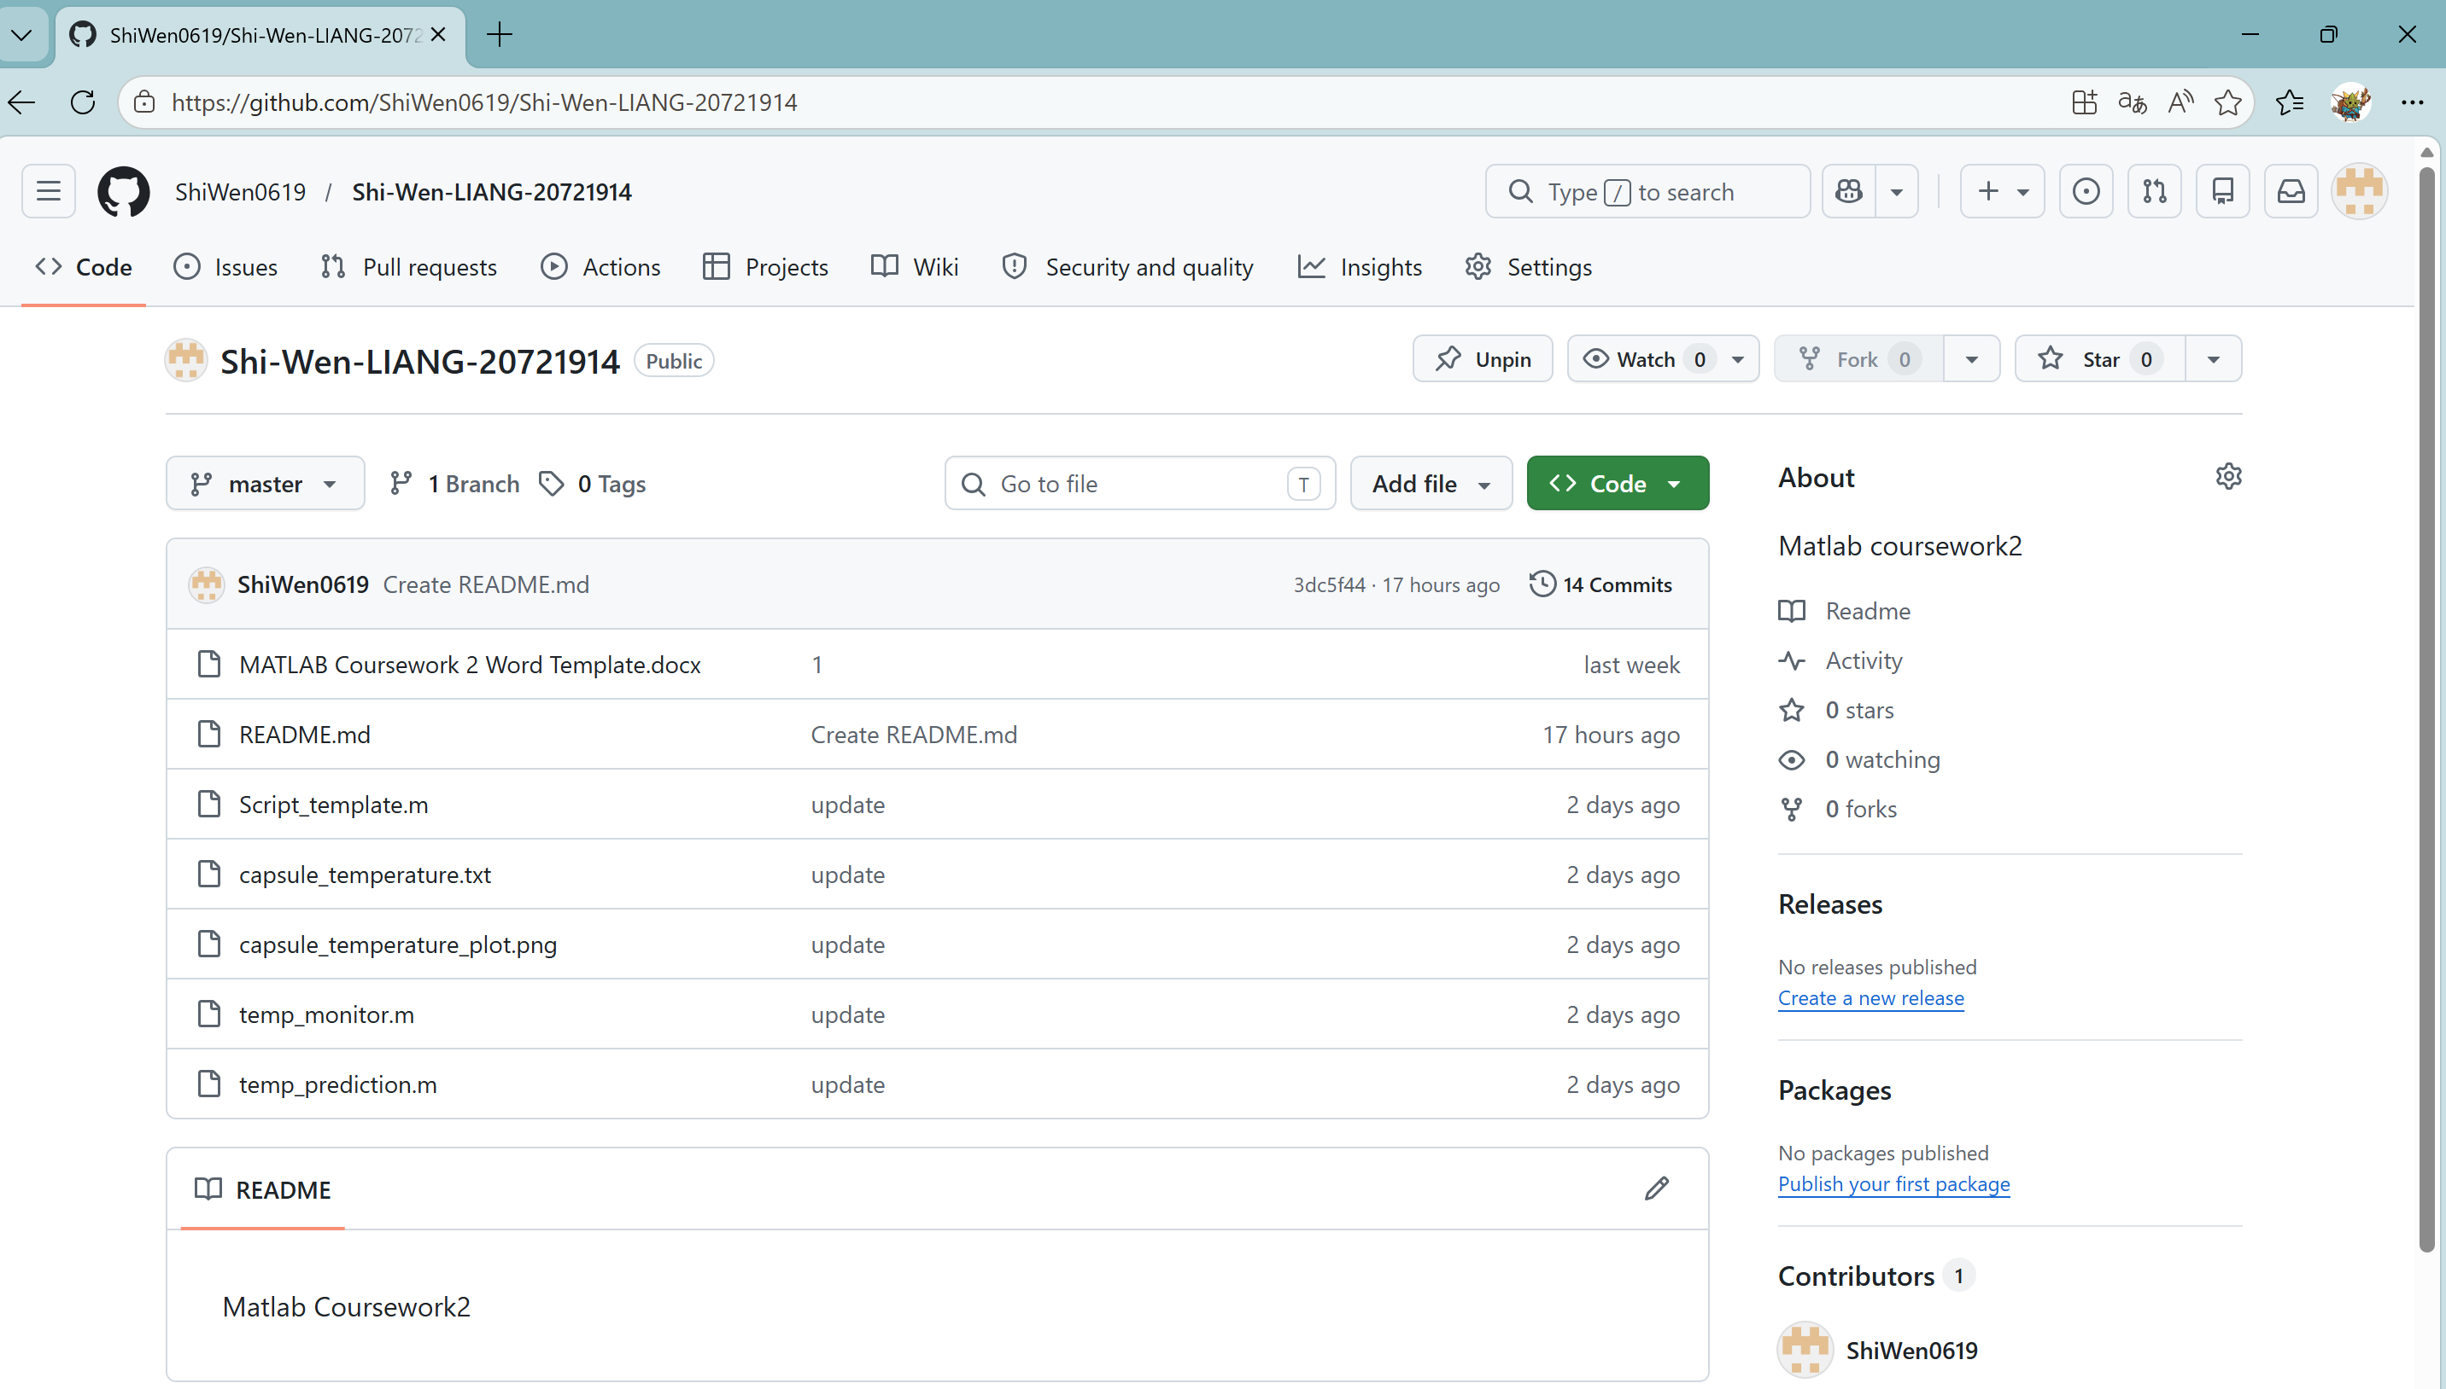
Token
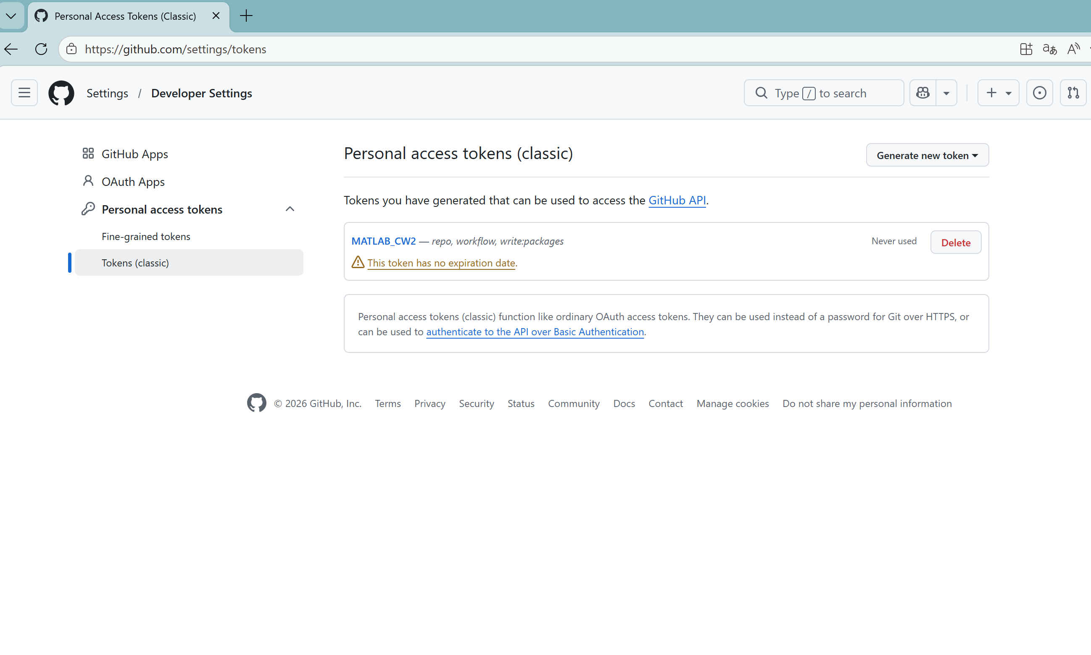

Content in Github
I have updated and submitted many times.
